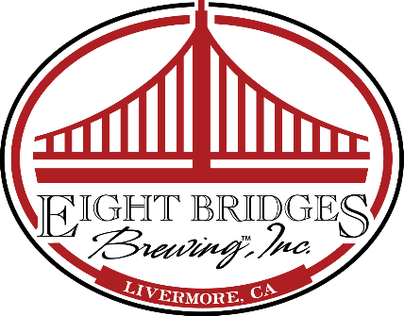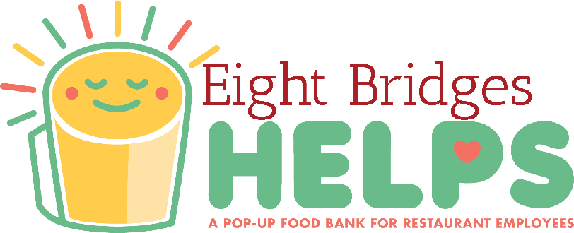

NEWS RELEASE

Eight Bridges Brewing, Inc. To Launch “Eight Bridges Helps” April 24th
Pop-Up Food Bank to Support Restaurant Workers During COVID-19 Pandemic

April 21, 2020 – Livermore, Calif. -- Eight Bridges Brewing, Inc. (www.eightbridgesbrewing.com) has teamed up with Livermore-based Performance Foodservice-Northern California, Pale Fire Brewing Co, Inc., and Digital Minerva to launch Eight Bridges Helps, www.eightbridgeshelps.com. The pop-up food bank concept was created to support restaurant workers during the COVID-19 crisis. Eight Bridges is the first West Coast location to replicate the Pale Fire Brewing Helps program begun in Harrisonburg, Va.

On Friday, April 24, 2020, the Eight Bridges Helps food bank will be open at Eight Bridges Brewing, Inc.’s tap room located at 332 Earhart Way in Livermore, Calif. It will be open to restaurant industry workers only from 12 noon-6:00 p.m. on April 24th and every Monday, Wednesday, Friday, and Saturday as long as the program can safely continue to operate and items are available.

All restaurant workers from the East Bay and beyond are welcome and will be asked to show their most recent pay stub to confirm eligibility. Out-of-towners should call Eight Bridges Brewing at (925) 961-9160 to confirm food availability before making the trip.

A variety of non-perishable items donated by Performance Foodservice-Northern California will be distributed. Participants are asked to bring a reusable shopping bag and take only what they immediately need. Strict sanitation and social distancing measures will be followed at all times. Restaurant workers can learn more at www.eightbridgeshelps.com.

“We all know the restaurant industry has been hit particularly hard as our country practices necessary social distancing,” says Justin Beardsley, co-founder and brewmaster at Eight Bridges Brewing, Inc. “Eight Bridges Helps is intended to provide tangible support to restaurant workers when, with little warning, hundreds of cooks, servers, bussers, and cashiers in our area have found themselves without income. At times like this, something as simple as groceries can go a long way. We are excited and grateful to find such generous partners in Performance Foodservice- Northern California and Digital Minerva (which created our website pro bono) to make our pop-up food bank happen. “

For the public: Eight Bridges Brewing is also accepting both shelf-stable food and monetary donations to support Eight Bridged Helps program, as well as volunteers. Learn more about how you can help at www.eightbridgeshelps.com. Eight Bridges Brewing’s tap room will remain open to the general public for pre-ordered to-go beer purchases only.

About Eight Bridges Brewing, Inc.
Eight Bridges Brewing, Inc. opened in February 2014 as the first family-owned brewery in Livermore. Calif. The brewery is focused on producing exceptionally fresh, local, and Independent Craft Beer and creating a great craft beer experience. Eight Bridges offers a broad range of ales and lagers, each designed, brewed and packaged with no compromise - always balanced. Taproom visitors experience the feel of a brewery because they are in the middle of one. Eight Bridges is the original family and dog friendly tasting room in Livermore, located just off US 580 adjacent to the Livermore Airport. www.eightbridgesbrewing.com.

# # # # #

Note to Editor/Assignment Desk: Eight Bridges Brewing Co-Founder and Brewmaster Justin Beardsley is available for interviews. Contact him at (925) 998-0455 (cell) or justin@8bridgesbrewing.com.

Media Contact Only
Barbara Lewis
Attention! Business Communications
for Eight Bridges Brewing
925.413.6540 (talk & text)

