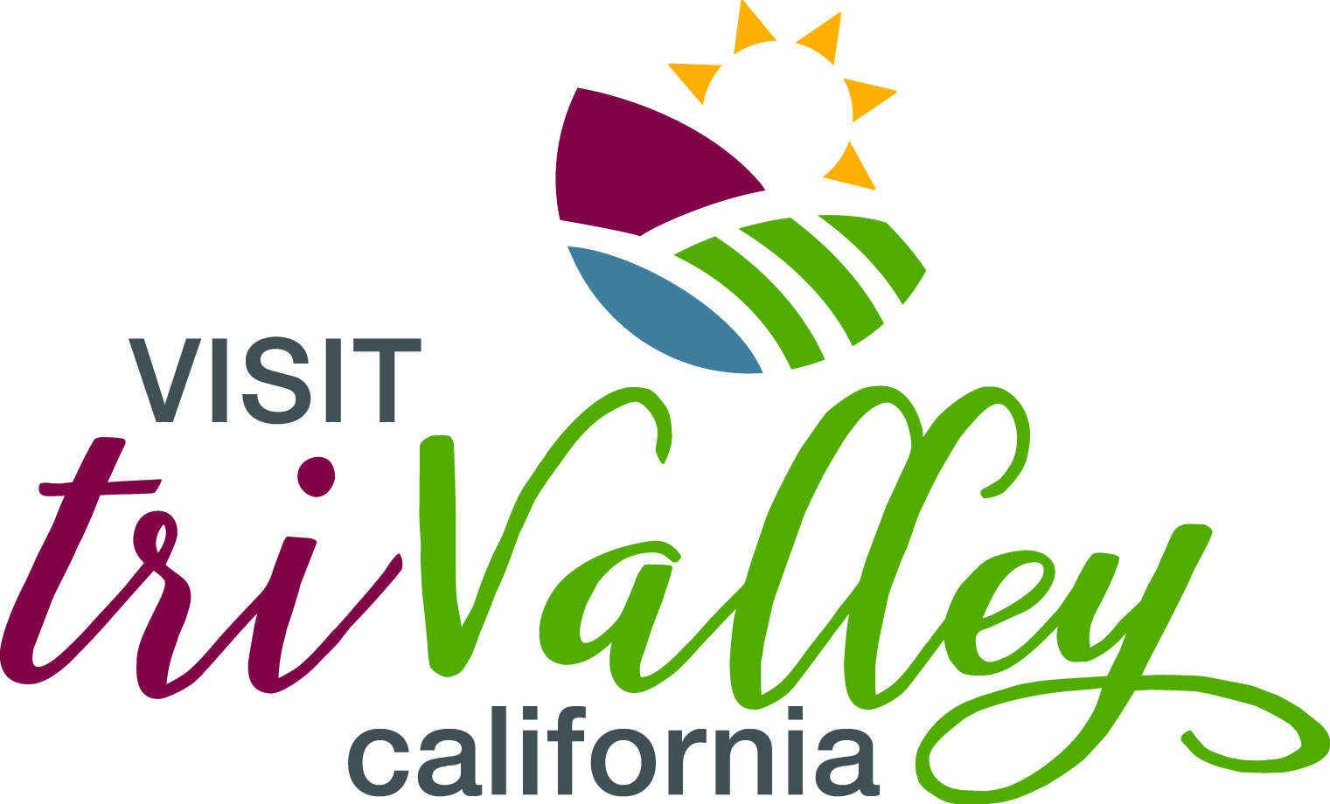

Design & Research Manager Effective Date: 3/16/2023

Reports to: CEO & Vice President of Marketing Supervises: None

Status: Exempt

_____________________________________________________________________________________________

ABOUT VISIT TRI-VALLEY

Visit Tri-Valley is the destination marketing organization (DMO) for the Tri-Valley region, which is comprised of the town of Danville and the cities of Pleasanton, Livermore and Dublin and its three valleys (Amador, Livermore and San Ramon). Located just 33 miles east of San Francisco and 27 miles north of San Jose, the Tri-Valley boasts an historic wine region with nearly 60 wineries, a craft beer trail, award-winning golf courses and regional parks, historic museums and attractions as well as diverse shopping at premium outlets and chic boutiques in authentic downtowns.

Visit Tri-Valley’s mission is to bring visitors for overnight stays by promoting the assets of the region. This is accomplished through an extensive marketing and sales program of work.

Job Description: Design and Research Manager responsible for implementing team goals and mission, including creative design work, research and data reporting, promotions, and advertising collaboration. Reports directly to VP of Marketing and CEO; full-time salary position depending on experience; equal opportunity employer, with benefits. In-office position. Flexible work schedule. Available immediately. Open until filled

JOB RESPONSIBILITIES

Graphic Designer
- Annual report creation
- Marketing Campaigns and Collateral (maps, POI’s, Visitor Guide additions)
- Website Carousels and page design
- Invitations/Save the Dates/posters
- Survey creation and distribution
- Power Point presentations for executive speaking engagements
- Local and regional partner advertising and sponsorship
- Sports development collateral artwork
- Additional design creative, placement and scheduling as needed

Assistant to CEO and Director of Sports Development
- 5-yr Strategic Plan research, coordination, and collaboration with community members
- Economic Impact Calculator data analysis
- Asset inventory Research/Data entry
- Department reporting curation
- CMS Data Entry
- Photography for internal and external use
- Database creation (upkeep) for all event pictures
- Assistance (if needed) for large sports events within the Tri-Valley

Event Planning/Attendance Team Player
- ‘I Am Tri-Valley’ educational training events
- Marketing Mixers
- Tradeshow representation
- Media assistance / FAM coordination
- Annual Luncheon production and implementation
- Taste Tri-Valley Restaurant Week
- Other events as needed

Website Updates and Management
- Help populate new events portal
- Manage Hotel pages/promotions with booking engine
- Regular partner updates, new graphics, landing pages, etc.

Dropbox Management

Video Creation
- Editor
- Tik Tok content

Interchange tasks within marketing department for fulfilling social media, writing, monthly newsletters, Podcast, advertising placements, in-market activations, and promotions, etc. as needed.

QUALIFICATIONS
- Bachelor’s degree in graphic arts/ marketing/communications, event planning and hospitality or equivalent work experience.
- Excellent organizational and detail-oriented skills.
- Process oriented.
- Excellent written and verbal communication skill.
- Proficient in Mac operating systems and related programs (Microsoft Office, iDSS, Microsoft Word, Excel, PowerPoint, etc.).
- Excellent phone and computer skills.
- Knowledgeable user of social media and the Internet.
- Demonstrate the ability to apply critical thinking skills and suggest and/or resolve daily concerns.
- Demonstrate the ability to be open-minded and willing to learn.
- Demonstrate the ability to manage, prioritize, and work on several projects with overlapping deadlines.
- Demonstrate the ability to engage in social/networking events, building business relationships with others as a representative of company values.
- Demonstrate the ability to work independently and to be self-motivated.
- Demonstrate the ability to work as a team player.
- Demonstrates professional, outgoing and friendly demeanor.
- General working knowledge of the Tri-Valley region a plus.

PHYSICAL DEMANDS/WORK ENVIRONMENT
- Ability to travel as needed; must have a valid driver’s license, clean driving record, reliable transportation with adequate insurance.
- Must be available to work occasional nights and weekends.
- Must be able to work amongst team members in a standard office environment that may require frequent movement around the office and able to move equipment up to 35 lbs.
- Extensive use of computer and keyboard required for most of the workday.
- Must have the ability to focus on multiple tasks simultaneously and perform work in a high-paced, high-energy environment.

